when an individual user wants to enter multiple individual values or select a value range, we need to install them in a table in memory that our program can use.

An internal table we create for a select table has a similar restriction to parameters in that we can only give them a name of up to eight characters in length. And the select tables themselves contain four separate fields, which get defined when we create our select-option statement. These fields are sign, option, low, and high.

When a user makes a choice by filling in a selection field on the screen, whether that is a single value or range of values, a record is generated, and put into this internal table. And because it's a table, this allows the user to enter as many records, as they wish. And all these records will be used to filter our data.

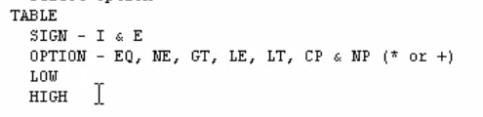

Now the sign field has a data type of c, a character, with a length of one. The data stored in this field determines, for each record, whether the record is to be included or excluded from the result set that our report selects. And the possible values that get stored in this field are I and E. Now, I stand for inclusive, so we are including the criteria, and E stands for exclusive, it's an exclusion criterion.

At the options field also has a type of c character, but this one has a length of two. And this field holds the selection operator. So, for example it can hold a value of EQ for equals and E for not equals. GT, And we have a couple of special ones CP, and lastly, NP. And as you can see, they're the same type of logical operators as those that are used for logical expressions, but CP and NP do not have the full functional scope they have in normal logical expressions. Now if wild card characters are entered onto the selection screen, the system will automatically use the operator CP.

Now the low field is used to enter the lower limit for a range of values that a user can enter.

the high field is used as the upper limit for a range of values. Now both are low and high fields. The data type is determined by the database table to which our selection criteria is linked. So, the data type will vary.





When we define a select-option field that refers to a database table field, the attributes of that field will automatically apply to the input fields on the selection screen.

They can exclude certain values, and they exclude ranges of values too. The select-option is so much more functional in a single parameter field.

Users can now entire a single value into the low field, which is this one on the left, and they can also enter a value into the right-hand field which is the high field.

Now if a user didn't enter anything into this field, and our table is going to be blank. It won't have, any records generated.

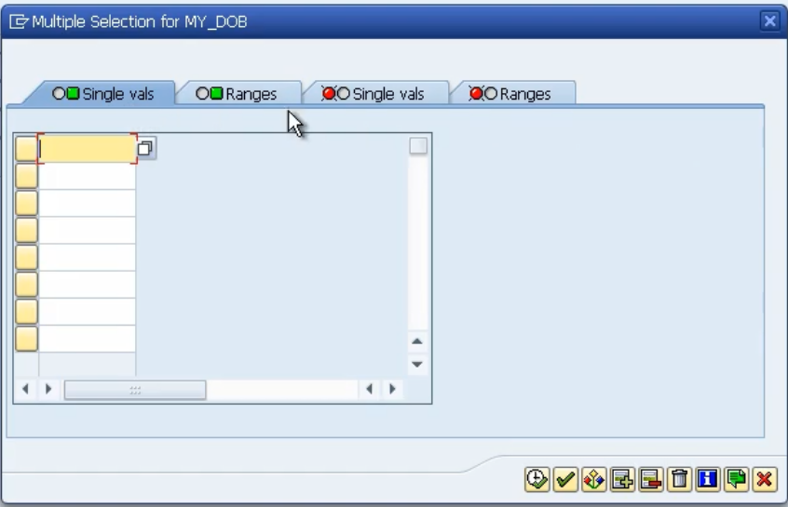

And you might be wondering what's that button on the right? Well, this is where, we get a load more functionality.

Let me click it and then, I will explain. So now we get this pop-up box. And as you can see, we got four tabs along the top. Here we can enter individual single values for this field. And it doesn't matter what sequence you put them in. You can enter as many individual values as you wish.

Now, you'll notice, two of these tabs have got the green square, and then two have got red circles. So, the green, that indicates we're going to include values in our selection criteria. And if we click on to the red, any values we enter here, will be excluded.

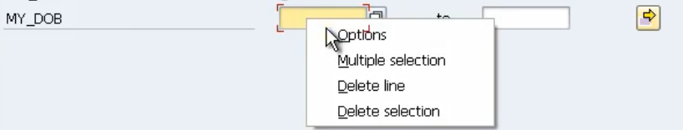

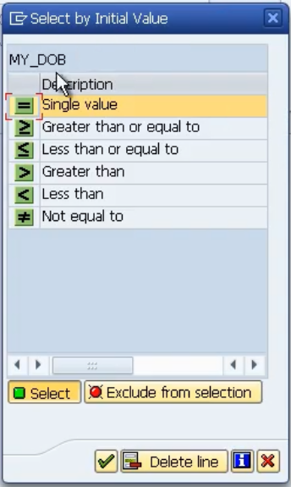

you can include wildcard characters and things like that, but you can also include the logical operators,

If I right-click here and choose Options, then we get a list of logical operators that we can assign to the individual fields on our select-option records so by default. It's always going to use the equal sign.

But if we want it to say less than or equal to, we can double-click, and we get the little graphical representation of less than and equal to, and then we can fill in the value.